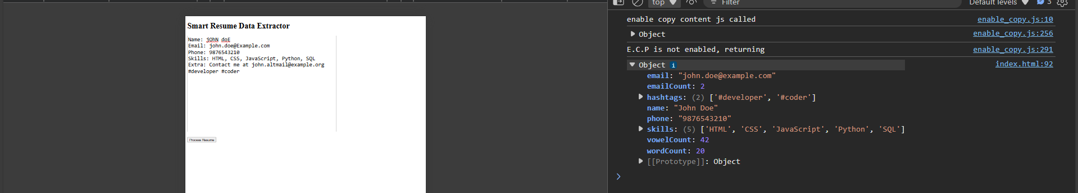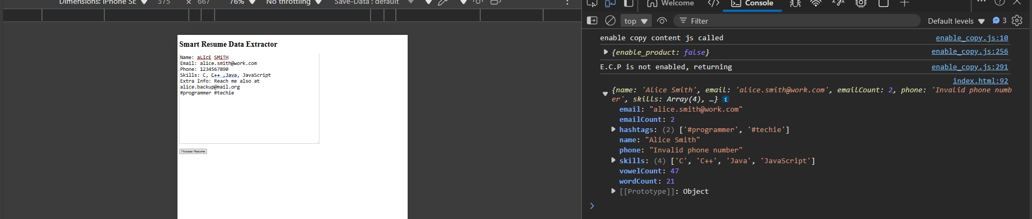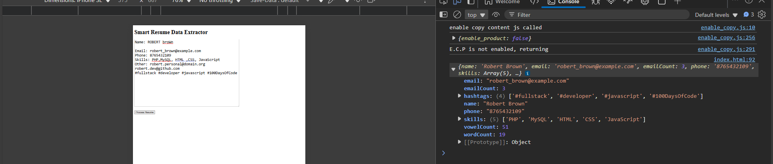
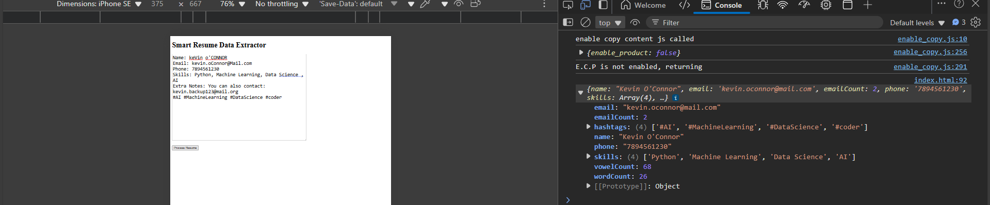
<!DOCTYPE html>
<html lang="en">
<head>
<meta charset="UTF-8" />
<title>Smart Resume Data Extractor – Robust Version</title>
</head>
<body>
<h1>Smart Resume Data Extractor – Robust Version</h1>

<textarea id="resumeInput" rows="15" cols="80" placeholder="Paste resume text here..."></textarea><br><br>
<button onclick="handleResume()">Process Resume</button>

<script>
// 1. Format Name – handle hyphens, apostrophes, dots
function formatName(rawName) {
if (!rawName) return "Not provided";
let name = rawName.trim().replace(/\s+/g, ' ');
let words = name.split(' ');
let formattedWords = words.map(word => {
// Handle apostrophes, hyphens, dots
return word.split(/(['\-\.])/).map(part => {
if (/['\-\.]/.test(part)) return part;
return part.charAt(0).toUpperCase() + part.slice(1).toLowerCase();
}).join('');
});
return formattedWords.join(' ');
}

// 2. Extract all emails in the text
function extractEmails(text) {
let emailRegex = /\b[A-Za-z0-9._%+-]+@[A-Za-z0-9.-]+\.[A-Za-z]{2,}\b/g;
let matches = text.match(emailRegex);
return matches || [];
}

// 3. Validate Mobile Number – allow spaces, hyphens, country codes like +91 or 91
function validateMobile(number) {
if (!number) return "Not provided";
// Remove non-digit characters
let cleaned = number.replace(/[^0-9]/g, '');
// Remove leading country code if exists
if (cleaned.length > 10) {
cleaned = cleaned.slice(cleaned.length - 10);
}
let valid = /^[6-9]\d{9}$/.test(cleaned);
return valid ? cleaned : "Invalid phone number";
}

// 4. Extract Skills – allow label variations
function processSkills(text) {
if (!text) return [];
return text.split(',').map(skill => skill.trim()).filter(skill => skill.length > 0);
}

// 5. Extract hashtags anywhere in the text
function extractHashtags(text) {
let hashRegex = /#[A-Za-z0-9_]+/g;
let matches = text.match(hashRegex);
return matches || [];
}

// 6. Word Count
function countWords(text) {
return text.trim().split(/\s+/).filter(word => word.length > 0).length;
}

// 7. Vowel Count
function countVowels(text) {
let vowels = text.match(/[aeiouAEIOU]/g);
return vowels ? vowels.length : 0;
}

// Flexible field extractor using multiple possible labels
function extractField(text, possibleLabels) {
for (let label of possibleLabels) {
let regex = new RegExp(label + '\\s*[:\\-]\\s*(.+)', 'i');
let match = text.match(regex);
if (match && match[1]) {
return match[1].trim();
}
}
return "";
}

// Main processing function
function processResume(resumeText) {
let output = {};

// Name extraction – look for "Name", "Full Name", etc.
output.name = formatName(extractField(resumeText, ["Name", "Full Name"]));

// Emails
let emails = extractEmails(resumeText);
output.email = emails.length > 0 ? emails[0].toLowerCase() : "Not provided";
output.emailCount = emails.length;

// Phone extraction – look for "Phone", "Phone Number", etc.
let rawPhone = extractField(resumeText, ["Phone", "Phone Number"]);
output.phone = validateMobile(rawPhone);

// Skills extraction – look for "Skills", "Technical Skills", etc.
let rawSkills = extractField(resumeText, ["Skills", "Technical Skills"]);
output.skills = processSkills(rawSkills);

// Hashtags
output.hashtags = extractHashtags(resumeText);

// Word count
output.wordCount = countWords(resumeText);

// Vowel count
output.vowelCount = countVowels(resumeText);

return output;
}

// Handle input and print output to console
function handleResume() {
const resumeText = document.getElementById('resumeInput').value;
const result = processResume(resumeText);
console.log(result);
}
</script>
</body>
</html>

